**Global malnutrition trends: a power bi analysis (1983-2019)**

**Introduction :**

ABC Company is conducting a comprehensive analysis of global malnutrition trends among children under five years old from 1983 to 2019. Using an extensive dataset from UNICEF, WHO, and the World Bank, this study examines key malnutrition indicators such as severe wasting, wasting, stunting, underweight, and overweight rates across various countries.

To better understand the relationship between malnutrition and economic status, the analysis categorizes countries based on income levels—low, lower-middle, upper-middle, and high-income—as well as classifications such as Least Developed Countries (LDC), Low-Income Food-Deficient (LIFD), Landlocked Developing Countries (LLDC), and Small Island Developing States (SIDS). By employing advanced data visualization techniques in Power BI, including stacked bar charts and line graphs, the project aims to identify significant trends and correlations that can inform policy-making and resource allocation.

Malnutrition remains a pressing global health challenge, disproportionately affecting children in lower-income regions. This study seeks to uncover key patterns in child malnutrition over time and determine how economic and geographic factors influence malnutrition rates. By leveraging historical data, the project will identify the most affected countries and regions, highlighting areas that require urgent intervention. The insights generated will help stakeholders prioritize efforts, develop targeted strategies, and implement data-driven solutions to reduce malnutrition and improve child health outcomes worldwide.

Scenario 1: Count of U5 Population (140)

This metric represents the number of observations related to the under-five population in the dataset. It indicates the sample size or the count of data points collected.

Scenario 2:Sum of Survey Sample (11M)

The total sum of survey samples collected is 11 million. This large sample size adds robustness to the analysis and findings, ensuring that the insights derived are based on a substantial amount of data.

Scenario 3: Sum of Underweight (2.08K)

The total number of underweight cases is 2,080. This highlights the prevalence of underweight conditions among children under five, which is a critical aspect of malnutrition to address.

Scenario 4: Sum of LDC,LIFD,LLDC or SID2 and Average of Stunting by Income Analysis

The visualization is about the average spending by income. The x-axis shows income classification, likely divided into segments, and the y-axis shows the average spending. There is a trend line that shows that as income classification goes up, average spending also goes up.

Scenario 5: Sum of Overweight by Country

The visualization is about the total number of overweight people in various countries, according to a dataset titled "Sum of Overweight".

Scenario 6: Sum of Overweight and Underweight under Income Classification.

The width of each ribbon segment (overweight or underweight) for a specific income level indicates the relative size of that population group within that income bracket. By following the ribbon's path, you can see if overweight or underweight populations become more or less dominant as income levels change.

Scenario 7: Sum of Income Classification

It represents the total income within each income bracket, but without knowing the number of people in each bracket, it's difficult to interpret. A high total could be due to a few very high earners or many people with moderate incomes. Labels for each income bracket (e.g., low, middle, high).

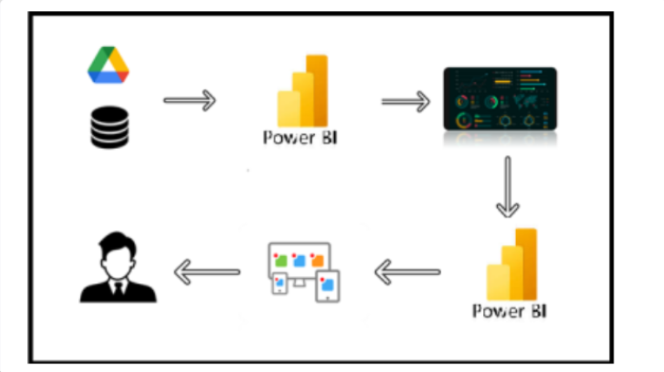

**Project Flow**

To accomplish this, we have to complete all the activities listed below,

* Data Collection
  + Collect the dataset,
  + Connect Data with Power BI
* Data Preparation
* Prepare the Data for Visualization
* Data Visualizations
  + Visualizations
* Dashboard
  + Responsive and Design of Dashboard
* Report
* Report Creation
* Performance Testing
  + Utilization of Data Filters
  + No. of Calculation fields
  + No. of Visualizations/Graphs
* Project Demonstration & Documentation
  + Record explanation Video for project end to end solution
  + Project Documentation-Step by step project development procedure

**Milestone 1: Data Collection & Extraction from Database**

Data collection is the process of gathering and measuring information on variables of interest, in an established systematic fashion that enables one to answer stated research questions, test hypotheses, evaluate outcomes and generate insights from the data.

**Downloading the dataset**

Activity 1.1: Understand the data

Data contains all the meta information regarding the columns described in the CSV files

Column Description of the Dataset:

* ISO code: Standardized two-letter country codes.
* Country: Name of the country.
* Survey Year: The year in which the survey data was collected.
* Year: The specific year of the data point.
* Income Classification: Income classification of countries (0: Low Income, 1: Lower Middle Income, 2: Upper Middle Income, 3: High Income).
* LDC: Indicator for Least Developed Countries (LDCs).
* LIFD: Indicator for Low Income Food Deficient (LIFD) countries.
* LLDC or SID2: Classification for Land Locked Developing Countries (1), Small Island Developing States (2), and Others (0).
* Survey Sample (N): The size of the survey sample.
* Severe Wasting: Average percentage of children with severe wasting.
* Wasting: Average percentage of children with wasting.
* Overweight: Average percentage of overweight children.
* Stunting: Average percentage of children with stunting.
* Underweight: Average percentage of underweight children.
* U5 Population ('000s): Population of children under five years old (in thousands).

**Milestone 2: Data Preparation**

Before visualizing the data, it is essential to ensure that it is properly structured and ready for analysis. This involves transforming the dataset into a format suitable for visualization, identifying key patterns and trends, filtering relevant subsets, and verifying its accuracy and completeness. Since the data has already been cleaned, the next step is to proceed directly with visualization to extract meaningful insights and enhance understanding of global malnutrition trends.

**Milestone 3: Data Visualization**

Data visualization involves transforming complex datasets into graphical representations, making the information more accessible and easier to interpret. By utilizing visual elements such as charts, graphs, and maps, this process helps highlight key patterns, trends, and anomalies, allowing for quick insights and better decision-making. The goal is to simplify data analysis and enhance understanding through clear, intuitive visuals.

**Global Malnutrition Trends(1983-2019)**

Activity 1.1: Count of U5 Population

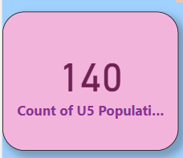

Activity 1.2: Sum of Survey Sample

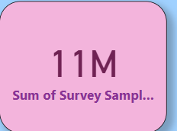

Activity 1.3: Sum of Underweight

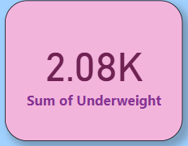

Activity 1.4: Sum of LDC,LIFD,LLDC or SID2 and Average of Stunting by Income Analysis

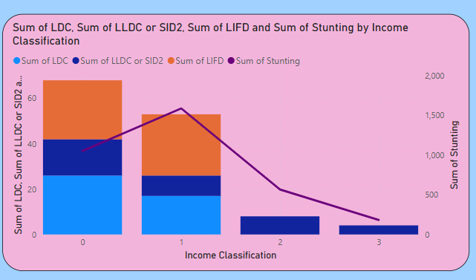

Activity 1.5:  Sum of Overweight by Country

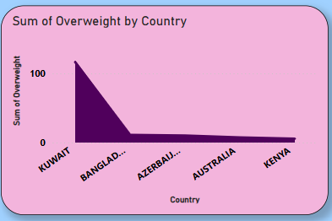

Activity 1.6: Sum of Overweight and Underweight under Income Classification.

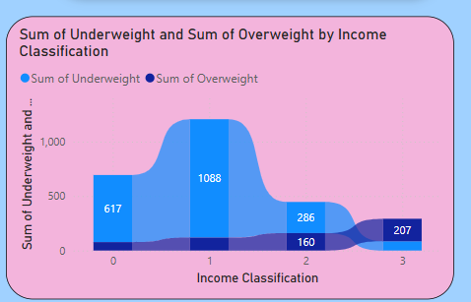

Activity 1.7: Sum of Income Classification

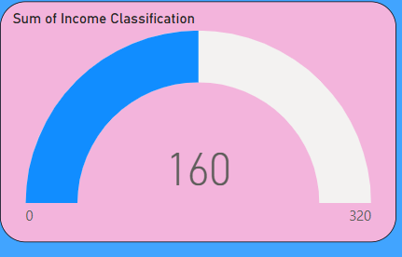

**Milestone 4: Dashboard**

A dashboard is an interactive interface that presents data in a structured and visually intuitive format. It is designed to provide real-time monitoring and analysis, helping users track key performance indicators (KPIs) and other important metrics. Dashboards utilize charts, graphs, and tables to display data effectively, making it easier to analyze trends and make informed decisions. They are widely used across various industries, including business, finance, healthcare, and manufacturing, to enhance data-driven decision-making.

**Activity 1- Responsive and Design of Dashboard**

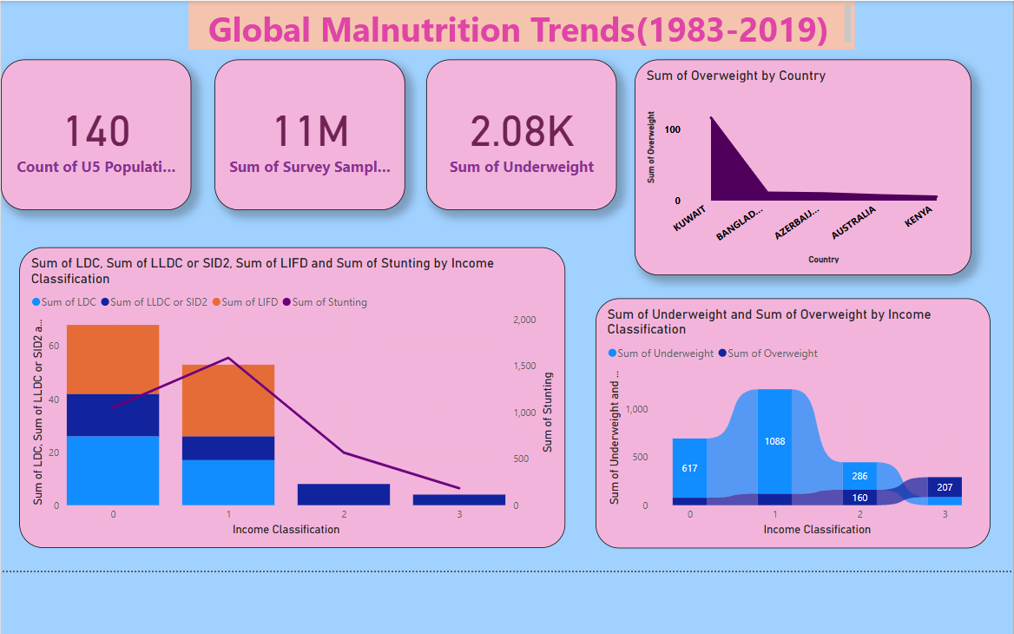

**Milestone 5: Report**

A report is a structured document that presents a detailed analysis of data, key findings, and insights. It serves as a tool for documenting and communicating results in a clear and organized manner. Designed for a wide audience, including decision-makers, analysts, and stakeholders, reports provide a comprehensive understanding of the data to support informed decision-making.

**Design of Report**

Creating a report in Power BI involves integrating data sources, developing visual elements such as charts and graphs, and customizing their appearance for clarity and interactivity. The visualizations are arranged logically to ensure a seamless flow of information, with consistent formatting for readability. Additionally, dashboards can be included to provide a high-level summary. The design process prioritizes the audience’s needs, ensuring the report effectively conveys key insights. Continuous refinement based on feedback enhances its clarity and effectiveness.

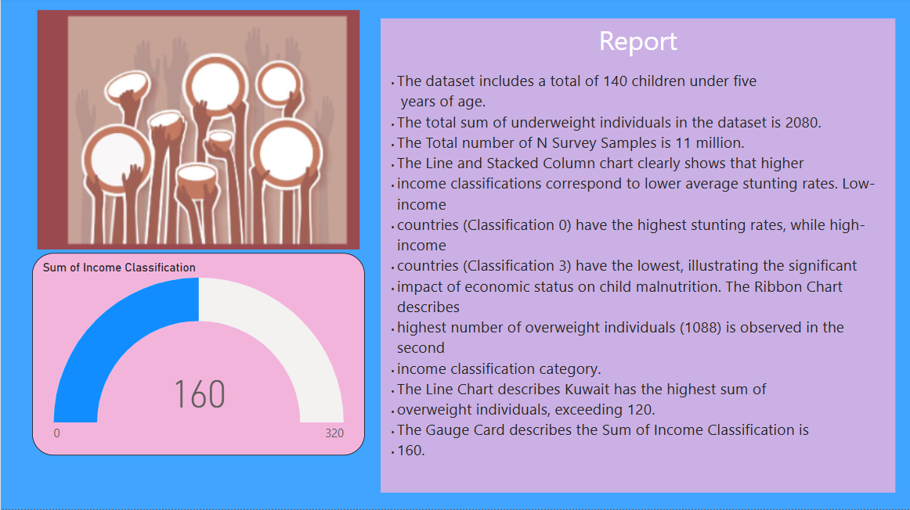

**Milestone 6: Performance Testing**

**Amount of Data Loaded**

The "Amount of Data Loaded" refers to the total volume of data imported into a system, software, or database for processing and analysis. It indicates how much data has been successfully retrieved and made available for use, ensuring it is ready for manipulation, visualization, and decision-making. This metric is crucial in assessing system performance and efficiency in handling large datasets.

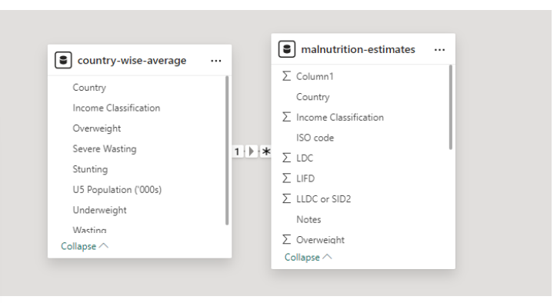

**Utilization of Filters**

"Utilization of Filters" refers to the process of applying filters in a system, software, or data pipeline to refine, sort, or analyze data based on specific conditions or criteria. Filters help in narrowing down datasets, making it easier to focus on relevant information for analysis and decision-making.

Activity 2.1: Selected “Country” as a Filter

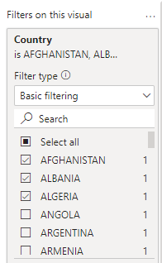

**No of Visualizations/ Graphs**

1. Count of U5 Population
2. Sum of Survey Sample(N)
3. Sum of Underweight
4. Sum of Overweight by Country
5. Total Income Classification
6. Sum of Overweight and Underweight by Income Classification
7. Sum of LDC, LIFD, LLDC or SID2 and Average of  Stunting by Income Analysis